

ASSIGNMENT

Topic

Coffee Management

Group 4:

Le Duc Hoa - Nguyen Thi Diem Huong

Vuong Dinh Nguyen - Nguyen Huu Ly

Can Tho, February 25, 2020

Feeback from Dr. HuongLH



......................................................................................................................................

......................................................................................................................................

......................................................................................................................................

......................................................................................................................................

......................................................................................................................................

......................................................................................................................................

......................................................................................................................................

......................................................................................................................................

......................................................................................................................................

......................................................................................................................................

......................................................................................................................................

......................................................................................................................................

......................................................................................................................................

......................................................................................................................................

......................................................................................................................................

......................................................................................................................................

......................................................................................................................................

......................................................................................................................................

Can Tho, February 25, 2020

Dr. HuongLH

**I**.**Introduction**

**1.ABSTRACT**

At present, information technology is considered a key industry of the country. Information explosion and the strong development of technology, to develop, need to apply information technology in different industries. Current software increasingly supports users to conveniently use, fast processing time. Therefore, when designing software, it not only requires accuracy and handling of many things, but also meets the speed, friendly interface and realistic simulation on the computer for users to use conveniently and accustomed belonging, high security, ... Software helps save and time of human efforts, increase accuracy and efficiency at work. As in managing a cafe. If not supported by computer software, the management needs to be quite a lot of people and divided into several stages to be able to manage the store such as managing employees (employees in shifts or all day), managing invoices , search, statistics and information adjustment, etc. These jobs require time and effort but the accuracy and efficiency are not high when doing manual work without using software. In addition, it will make the storage difficult, to consume large space, easy to lose and expensive. Meanwhile solving with 1 software is simpler.

Therefore, it is necessary to develop a cafe management program.

**II. Table Content**

1. **Introduction**

**II. Table Content**

**III. Basic Theory**

**3.1. The basic concept**

**3.2. The implementation tools**

**a. Netbeans**

**b. Java core, Java swing**

**c. SQL Sever 2017**

**3.3 Perform progamming**

**IV. Program analysis and design**

**III. Basic Theory**

**3.1 The basic concept**

Learn about the coffee shop's organizational structure. Learn about the business and process of coffee.

Survey the actual situation of the cafe.

Status: At present, information technology is considered a key industry of the country. Information explosion and the strong development of technology, to develop, need to apply information technology in different industries. Current software increasingly supports users to conveniently use, fast processing time. Therefore, when designing software, it not only requires accuracy and handling of many things, but also meets the speed, friendly interface and realistic simulation on the computer for users to use conveniently and accustomed belonging, high security, ... Software helps save and time of human efforts, increase accuracy and efficiency at work. As in managing a cafe. If not supported by computer software, the management needs to be quite a lot of people and divided into several stages to be able to manage the store such as managing employees (employees in shifts or all day), managing invoices , search, statistics and information adjustment, etc. These jobs require time and effort but the accuracy and efficiency are not high when doing manual work without using software. In addition, it will make the storage difficult, to consume large space, easy to lose and expensive. Meanwhile solving with 1 software is simpler.

Therefore, it is necessary to develop a cafe management program.

**3.2. The implementation tools**

**a. NetBeans**

Netbeans is a built-in development environment (IDE) for Java. NetBeans allows applications to be developed from a collection of software components called modules. NetBeans runs on Windows, macOS, Linux and Solaris. Netbeans has an intuitive interface, quite similar to that of most software today. This will help the user operation more simple and convenient. Although Netbeans is always associated with Java drafting, this software still has support packages for programmers to apply languages ​​like C, C ++, PHP, etc.

**b. Java Core, Java Swing**

Java is an object-oriented programming language (OOP) and is based on classes. Unlike most common programming languages, instead of compiling source code into machine code or interpreting source code at run time, Java is designed to compile source code into bytecode, which will then be executed by the execution environment ( runtime environment) run.

In the past, Java was slower than straight-forward languages ​​like C and C ++, but later thanks to "Just in time compilation" technology, this was solved, and in some schools Java special combinations can run faster. Java runs many times faster than interpreted languages ​​like Python, Perl, PHP. Java runs equivalent to C #, a language that is quite similar in terms of syntax and translation / run process

The Java syntax is heavily borrowed from C & C ++ but has a simpler object-oriented syntax and fewer lower-level processing features. Therefore, writing a program in Java is easy, simple and less time consuming to fix errors. But in terms of object-oriented programming, Java is more complex.

In Java, memory leaks are unlikely to occur because the memory is managed by the Java Virtual Machine (JVM) by automatically "clearing junk". Programmers do not have to care about allocating and deleting memory like C and C ++. However, when using network resources, IO files, databases (outside of JVM control) and programmers do not close (close) streams, data leakage can still occur.

**c. SQL Server 2017**

Microsoft® SQL Server® 2017 Express is a powerful and reliable free data management system that delivers a rich and reliable data store for lightweight Web Sites and desktop applications.

Microsoft SQL Server is a [relational database management system](https://en.wikipedia.org/wiki/Relational_database_management_system) developed by [Microsoft](https://en.wikipedia.org/wiki/Microsoft). As a [database server](https://en.wikipedia.org/wiki/Database_server), it is a [software product](https://en.wikipedia.org/wiki/Software_product) with the primary function of storing and retrieving data as requested by other [software applications](https://en.wikipedia.org/wiki/Software_application)—which may run either on the same computer or on another computer across a network (including the Internet).

Microsoft markets at least a dozen different editions of Microsoft SQL Server, aimed at different audiences and for workloads ranging from small single-machine applications to large Internet-facing applications with many [concurrent users](https://en.wikipedia.org/wiki/Concurrent_user).

**3.3.  Perform programming**

The program is built, database design on SQl Server and designed interface, writing programs on NetBeans with Java OOP.

**IV. Program analysis and design**

1. User interface

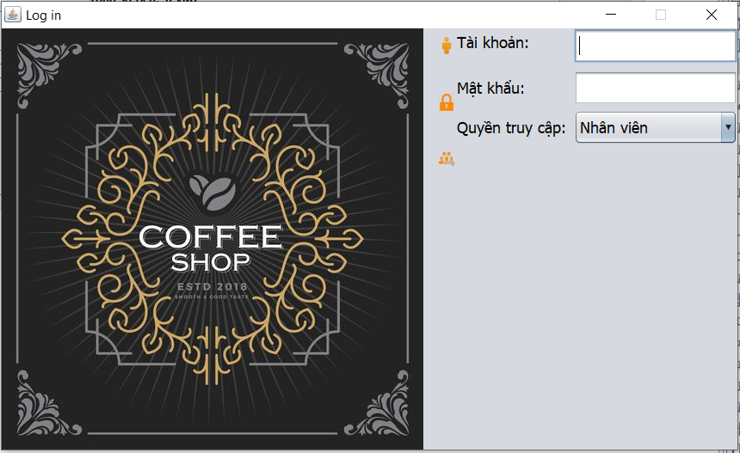

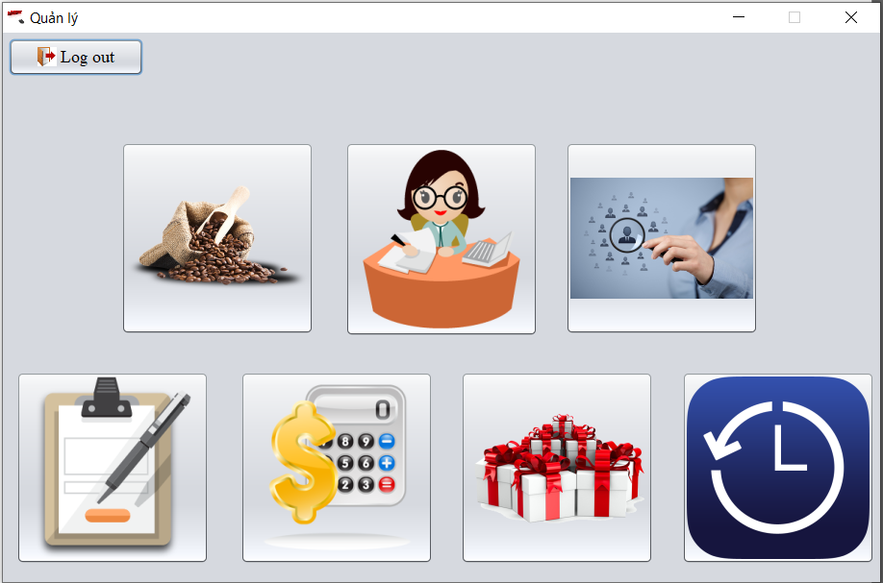

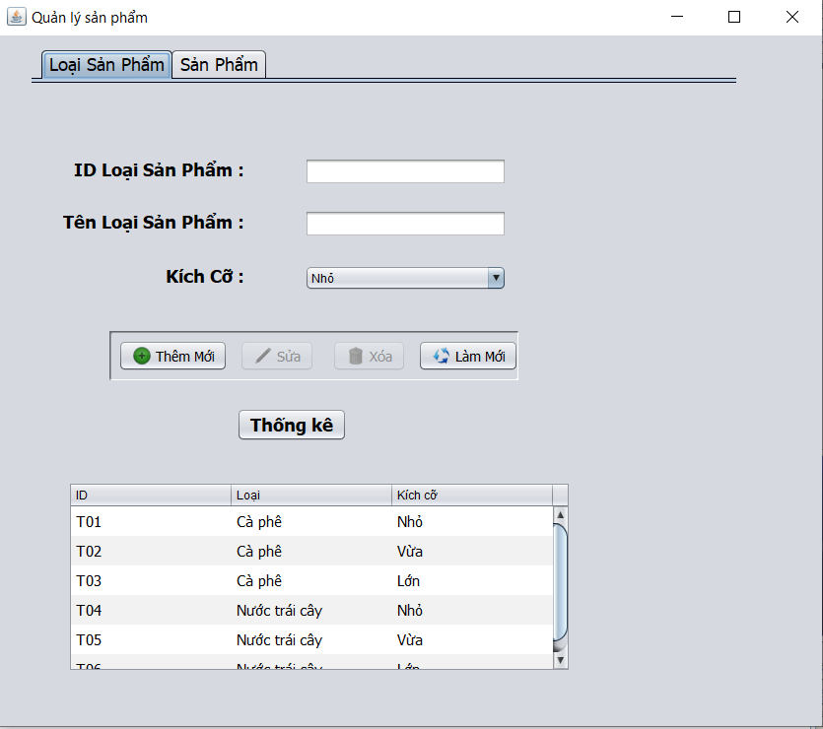

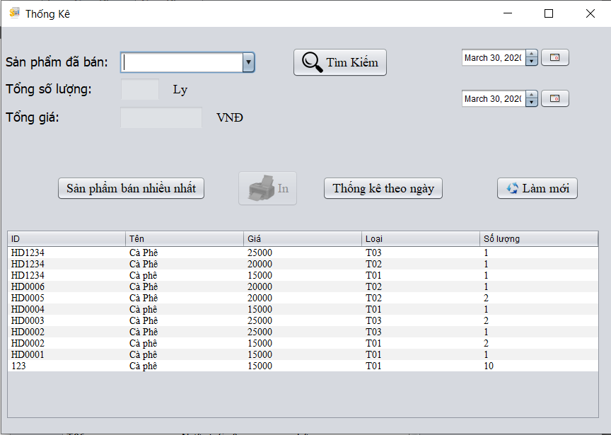

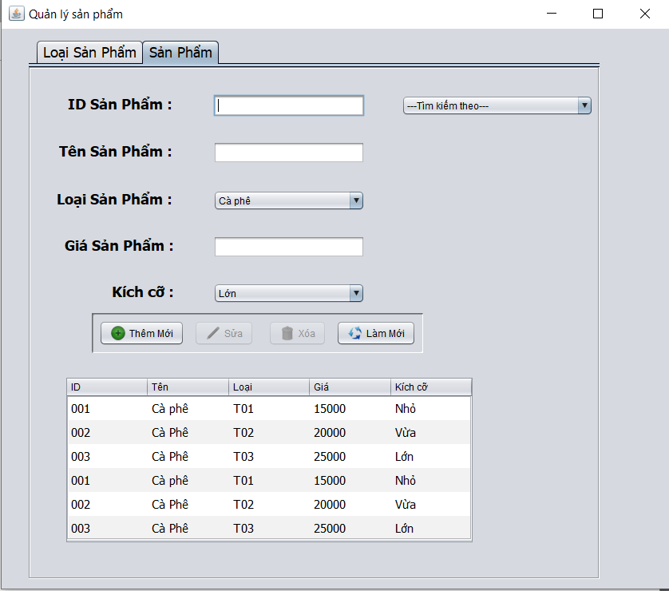

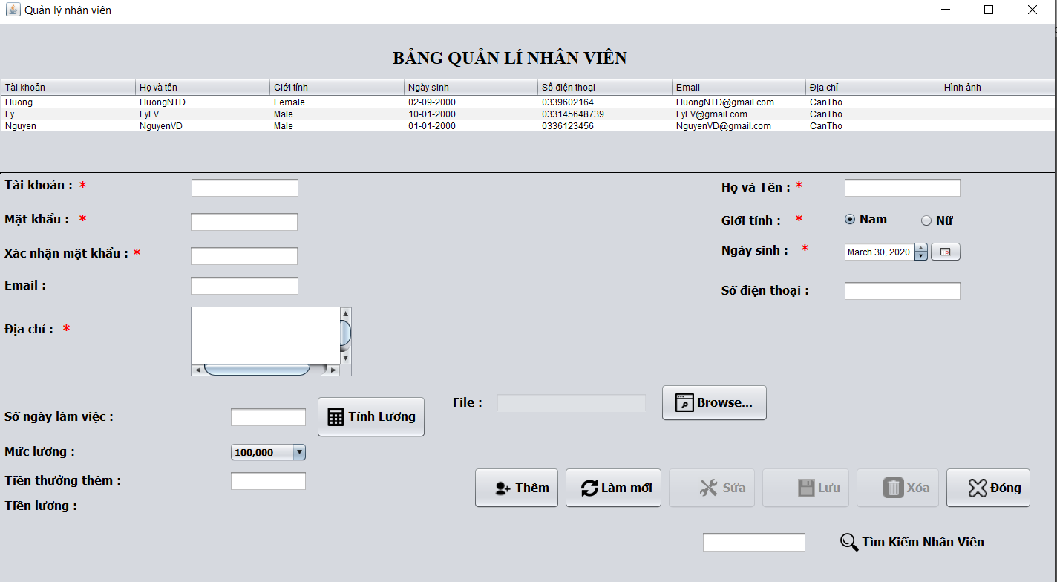

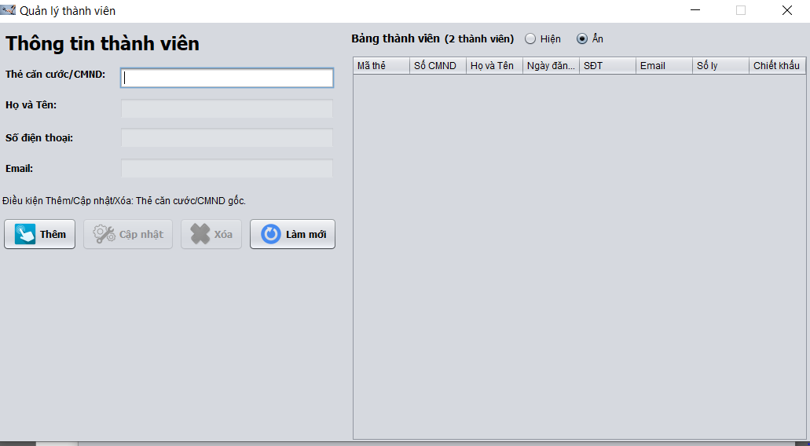

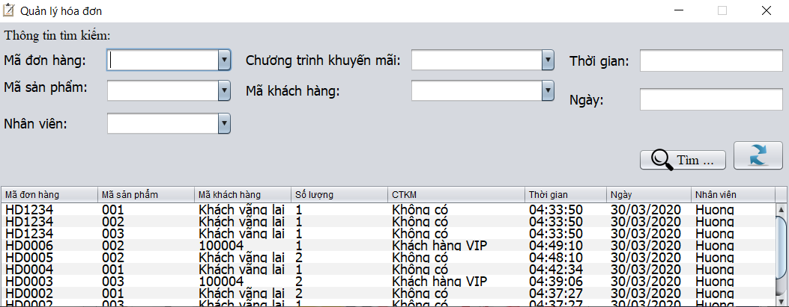

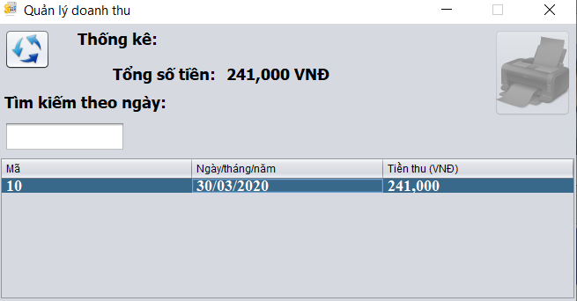

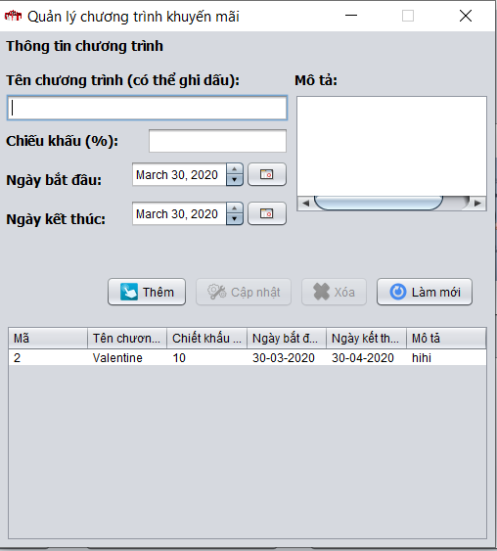

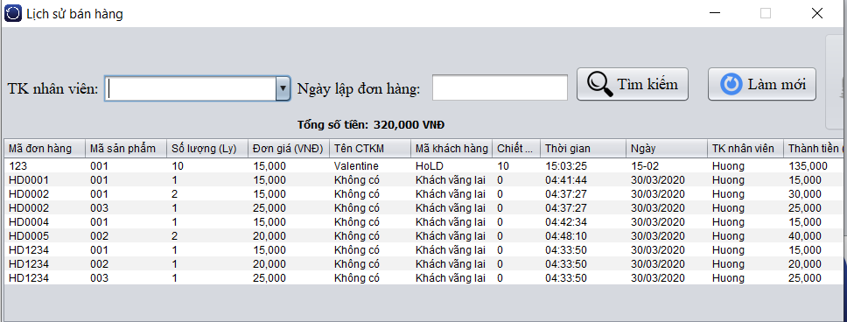

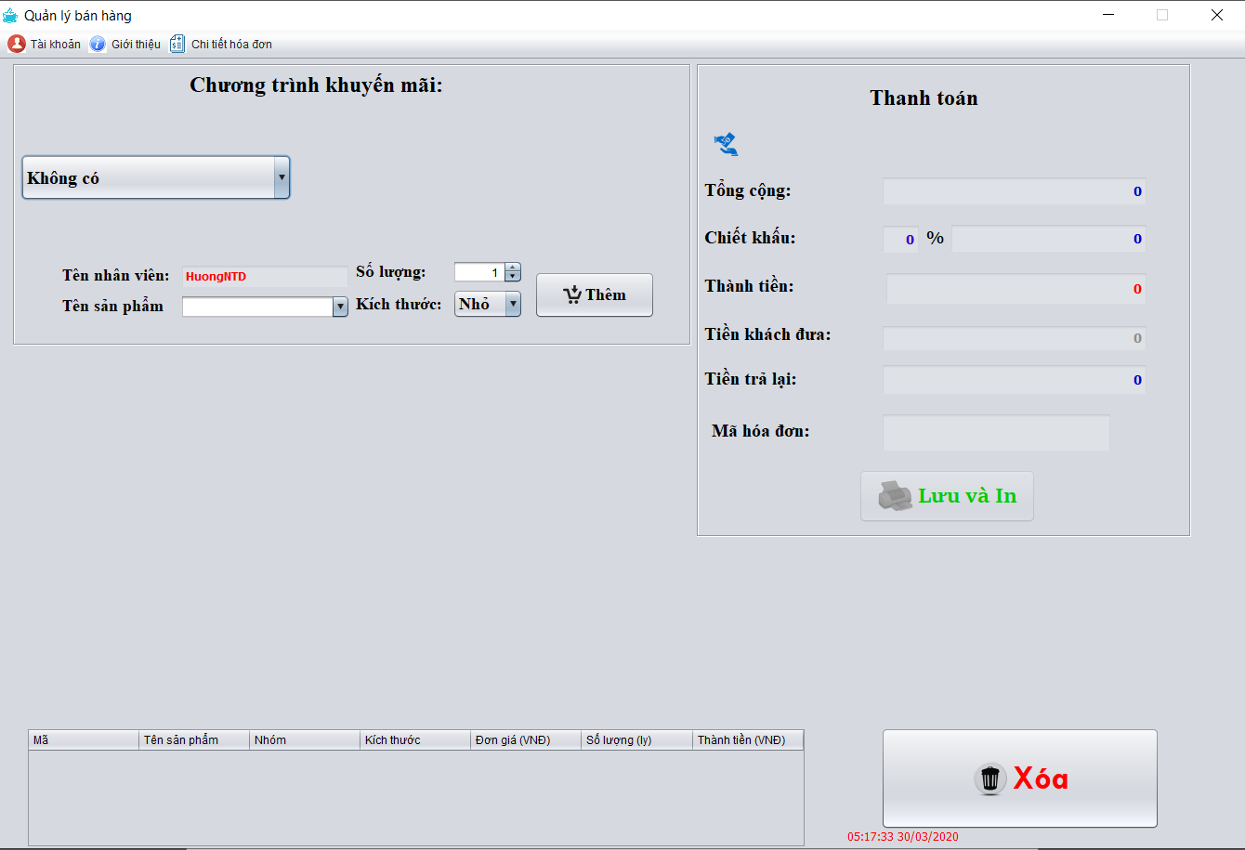

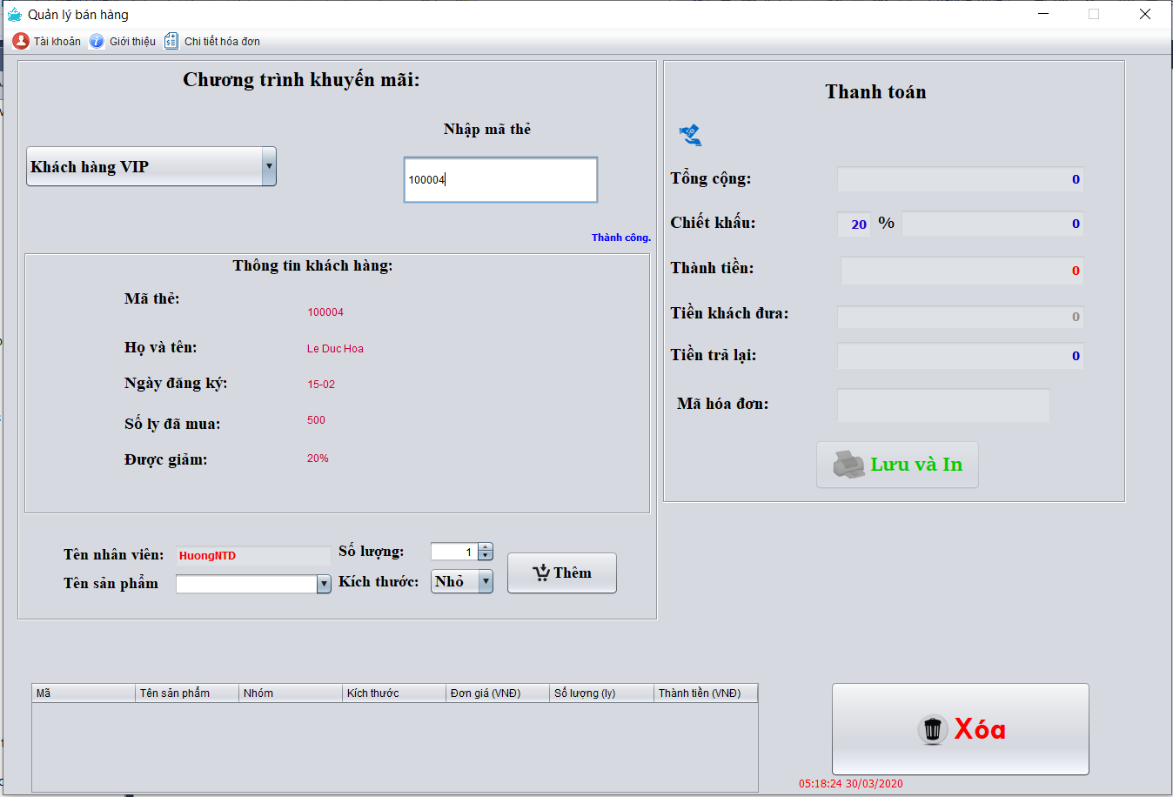

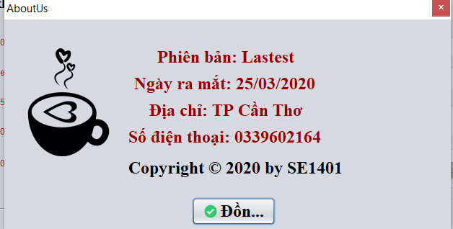

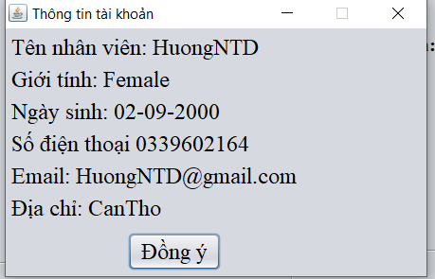

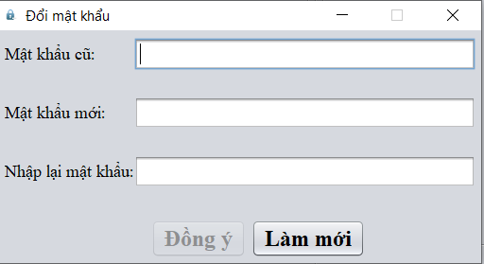

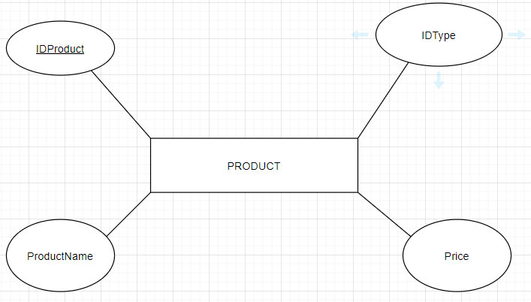**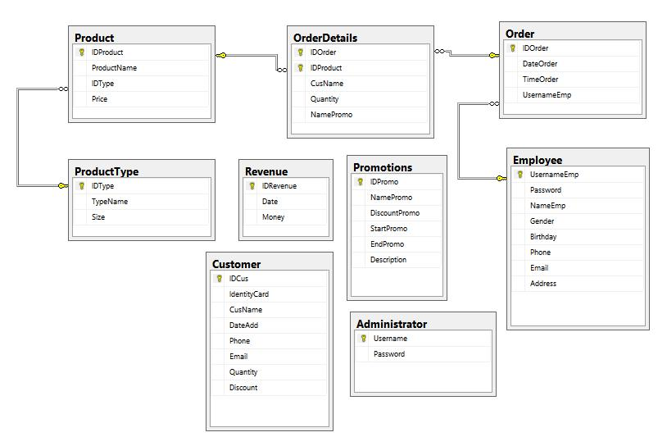2.Flow chart**

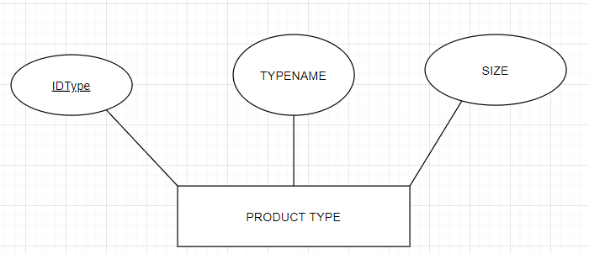

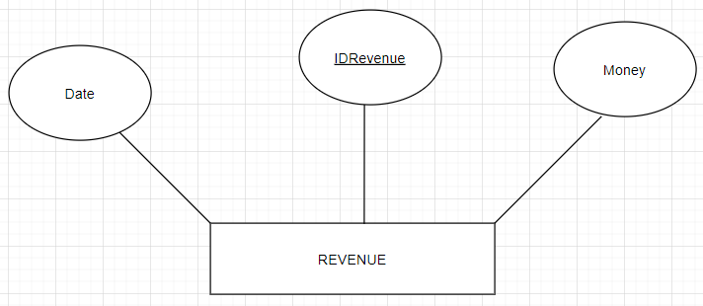

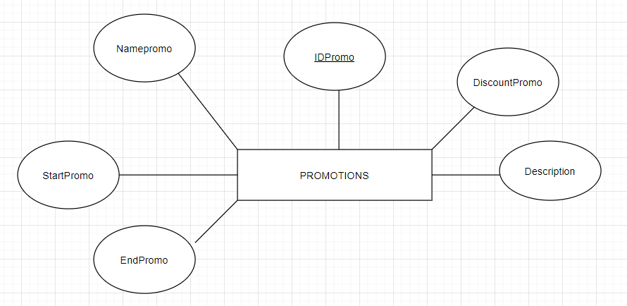

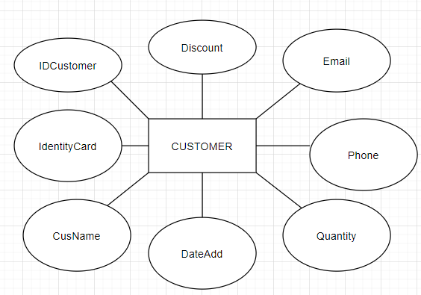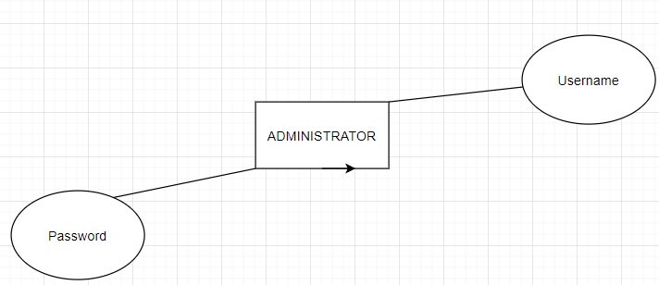

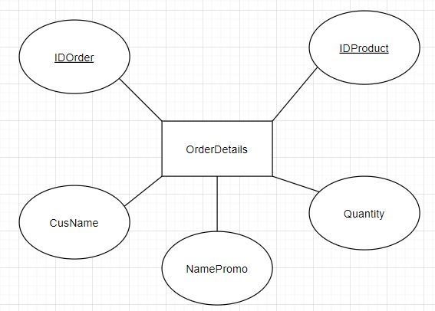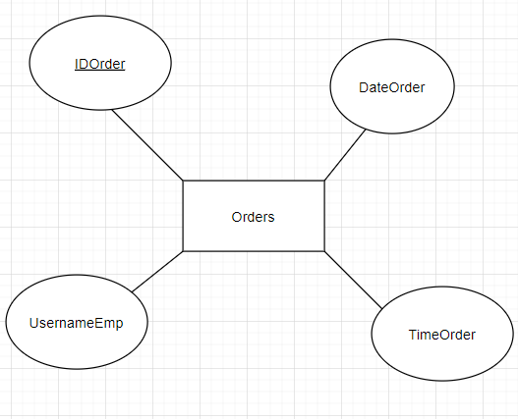

Thank you.